
Koneru Lakshmaiah Education Foundation
(Deemed to be University estd. u/s. 3 of the UGC Act, 1956)
Off-Campus: Bachupally-Gandimaisamma Road, Bowrampet, Hyderabad, Telangana - 500 043. Phone No: 7815926816, www.klh.edu.in

STUDENT CASE STUDY EXECUTION REPORT
Department | FED
Subject | DSA-2
Academic Year | 1-111 Semester | 2025-26
Faculty Name | LAHARI
Student Name | S.VENNELA
Roll Number | 2520080018
Branch | AI&DS
Course Outcome | 5
Case Study Topic: JobMatch Candidate Profile Indexing using merge sort
Work Done Summary:
In this case study, we designed and implemented a JobMatch candidate profile indexing system using Heap Sort, Counting Sort, Merge Sort, and Quick Sort (p. 1). Each candidate profile is stored as a record with a unique integer Candidate ID used as the key (p. 1). We analyzed comparison-based sorting routines like Merge Sort and Quick Sort to achieve an average time complexity of\(O(n \log n)\)(p. 1). We observed that unstructured datasets can lead to performance overheads; the system resolves this by performing runtime pivot optimizations in Quick Sort or by utilizing a max-heap structure to handle real-time streaming profile priorities in-place (p. 1). To optimize specialized categorical groupings, like experience brackets, Counting Sort was integrated to achieve linear\(O(n)\)efficiency (p. 1).

Implementation Details:
- Created a Candidateclass with fields: candidateID(key), name, skills, and
Experience.
- Implemented array-based processing to index 10 candidate nodes with explicit key sorting rules.
- Added weighted multi-attribute processing parameters to evaluate composite profile match scores.
- Developed Heap Sort using max-heap properties to efficiently extract the top-matching profiles.
5. Ran Counting Sort for a bounded experience scale to demonstrate instant non-comparison linear indexing.
6. Executed stable Merge Sort and randomized Quick Sort partitions on an
unarranged candidate distribution.
- Sorted 10 candidate IDs: 1045, 2310, 876, 3001, 1500, 422, 2800, 1600, 1750, 3200.
- Logged execution trends and compared algorithm suitability across different profile database sizes.

Result: Screenshots / Output
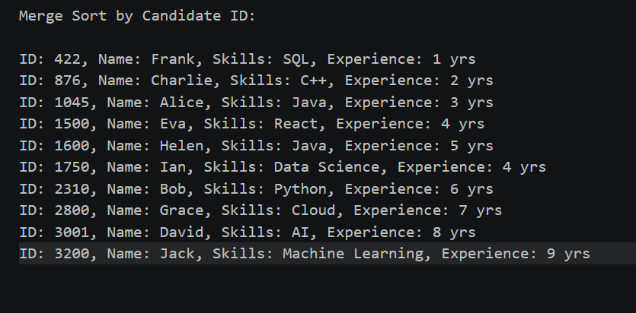
Time Complexity:-

Heap Sort: O(n log n)
Uses a max-heap structure to repeatedly extract the highest-priority candidate profile. Efficient for real-time ranking and priority-based candidate selection.

GETHUB LINK: https://github.com/SVennela07/dsa-2-case-study

Student Signature Faculty Signature

